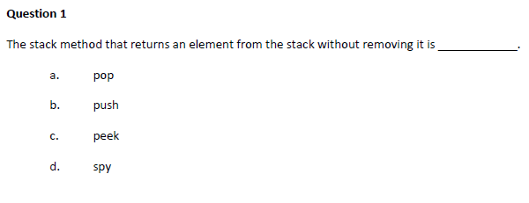
c. peek

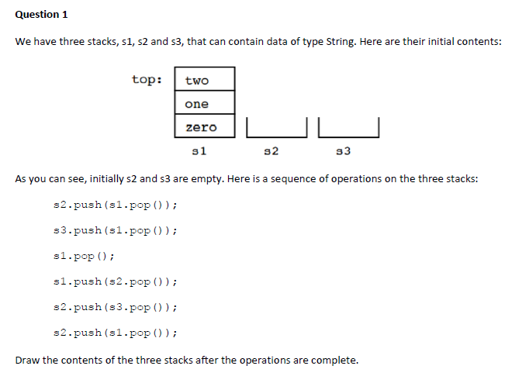
two
one
S2

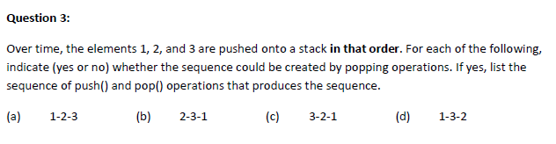
Push(1);
Push(2);
Pop();
Push(3);
Pop();
Pop();
Push(1);
Pop();
Push(2);
Push(3);
Pop();
Pop();

Yes
Push(1);
Push(2);
Push(3);
Pop();
Pop();
Pop();

Yes
No need do anything

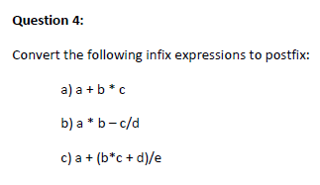

- b c * a +
- a b * c d / -
- b c * d + e / a +

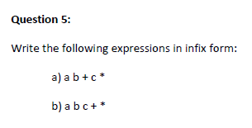

- (a+b) * c
- a * (b + c)

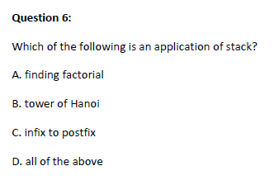

- Yes. It is an application of stack as (1 * 2 * 3 * 4 * … * n) as each multiplication of the whole number till n is an example of the number multiplying(stacking) on top of itself continuously for n times and increase by 1 each turn.
- Yes.
- Yes
- Yes

Hence answer is D

